**[What are 2-way, 3-way and 4-way matching in Account Payable?](https://www.zetran.com/)**

In the [**account payable process**](https://www.zetran.com/what-is-accounts-payable-process-and-end-to-end-process-of-ap) – the procurement and receiving stage, the 2-way, 3-way, and 4-way matching plays a vital role. It is worth investing in this control to make sure your business doesn’t pay for things you didn’t receive or overpay for things you did.

The topics important to know

* [What is matching?](https://www.zetran.com/what-are-2-way-3-way-and-4-way-matching-in-account-payable/#what-is-matching)
* [What are 2-way, 3-way, 4-way matching? Their difference.](https://www.zetran.com/what-are-2-way-3-way-and-4-way-matching-in-account-payable/#whats-are-2-way-3-way-and-4-way-matching-therir-difference)
* [Process of 2-way matching](https://www.zetran.com/what-are-2-way-3-way-and-4-way-matching-in-account-payable/##process-of-2-way-matching)
* [What is the Process of 3-way matching?](https://www.zetran.com/what-are-2-way-3-way-and-4-way-matching-in-account-payable/#process-of-3-way-matching)
* [Step by step process of 4-way matching](https://www.zetran.com/what-are-2-way-3-way-and-4-way-matching-in-account-payable/#process-of-4-way-matching)
* [The difference between 2-way Vs. 3-way matching](https://www.zetran.com/what-are-2-way-3-way-and-4-way-matching-in-account-payable/#difference-between-2-way-vs-3-way-matching)
* [Which is the better matching? 2-way or 3-way matching?](https://www.zetran.com/what-are-2-way-3-way-and-4-way-matching-in-account-payable/#2-way-or-3-way-matching-which-is-better)

## **What is matching?**

We perform the matching for goods and services ordered through your ordered purchase. Matching is a process that takes place during an online approval process. As applicable, the invoice matching is matched to 2-way, 3-way, and 4-way matching.  That is,

* 2-way matching – Purchase orders
* 3-way matching – Receives information
* 4-way matching – Inspect information

The invoice should meet the required tolerance matching or the invoice is on hold, where you cannot make the payment until they resolve the hold. The hold can also be realized manually.

**Key point:**Go to Settings - Modules and choose your matching requirement.

## **What are 2-way, 3-way, and 4-way matching? What’s their difference?**

If you’re an accountant you may be familiar with the topic – 2-way, 3-way, and 4-way matching. Let’s dive deeper to know more about what is 2 way, 3 way, and 4-way matching and their difference.

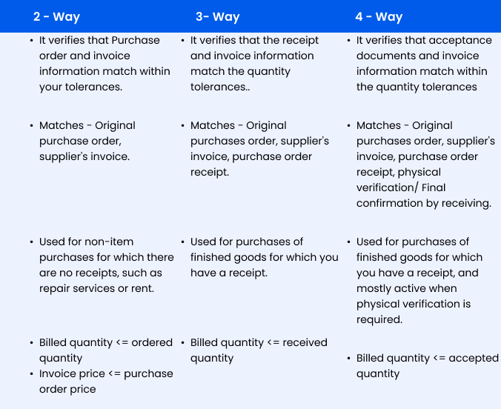

### **2-way matching**

In 2-way matching, you must verify that both the purchase order and the billing information match as followed below,

* Does the billed quantity is less than or equals to your ordered quantity?
* Does the price of the invoice is less than or equal to the purchase order price?

### **3-way matching**

In 3 way matching, the receipt quantity are compared to the invoice quantity. The 3-way matching defines,

* Does the billed quantity is less than or equal to your received quantity?

### **4-way matching**

Additionally, the 4-way matching verifies the acceptance document and the invoice matches the quantity. In this 4 way matching, it verifies,

* Does the Billed quantity is less than or equal to the accepted quantity?

## **Process of 2-way Matching**

In the process of 2-way matching, we match the invoice’s quantity and amount to the corresponding purchase order’s quantity and amount. Here follows the 2-way matching process.

**STEP 1:** The vendor/supplier will send an invoice for the goods/services payment ordered via the purchase order.

**STEP 2:**To match the purchase order, an invoice is created on the accounts payable module.

**STEP 3:**Step 3 is an online approval process. In this step, match the amount and quantity of the invoice to the purchase order. Make sure whether they met tolerances.

**STEP 4:**Two states occur,

* Tolerance meet
* Tolerance not meet

**If tolerance meets,**place no holds on the invoice. Finally, the invoice approves for payment.

**If tolerance does not meet,**place a hold on the invoice, and proceed for step 5.

**STEP 5:**Either the reason behind the hold should be fixed or proceed for manual release of the hold.

**STEP 6:**Repeat the invoice approval process once you resolve the hold. If tolerances met, the invoice is authorized for payment.

## **Process of 3-way Matching**

The process of 3-way matching arrives when an operating area uses an online receiving. In the 3-way matching process, you match the invoice with the respective quantity and amount of purchase order and the receiving information. Here follows the 3-way matching process.

**STEP 1:**Via thepurchase order, the goods or services ordered. These ordered goods or services – will be received either to the appropriate operating zone division or the central receiving.

**STEP 2:**Perform a query on the purchase module by receiving the form to discover the relevant purchase order.

**STEP 3:**Enter the information and save all the information, including the quantity received into the Oracle receiving form (transaction screen).

**STEP 4:**Record the delivered goods on oracle. Then perform manually for receipt by the end-user.

**STEP 5:**On the accounts payable module, prepare an invoice. Match the invoice to the purchase order (Note that the purchase order is created on purchasing module)

**STEP 6:**Step 6 is an online approval process. In this step, match the amount and quantity of the invoice to the purchase order and the information received. Make sure whether they met tolerances.

**STEP 7:**

Two states occur,

* Tolerance meet
* Tolerance not meet

**If tolerance meets,**place no holds on the invoice. Finally, the invoice approves for payment.

**If tolerance does not meet,**place a hold on the invoice, and proceed for step 8.

**STEP 8:**Either the reason behind the hold should be fixed or proceed for manual release of the hold.

**STEP 9:**Repeat the invoice approval process once you resolve the hold. If tolerances met, the invoice is authorized for payment.

## **Process of 4-way Matching**

The process of 4-way matching arrives when an operating area uses an inspection and online receiving. In the 4-way matching process, you match the invoice with the respective quantity and amount of purchase order, inspection information, and the receiving information.

**STEP 1:**Via thepurchase order, the goods or services ordered. These ordered goods or services – will be received either to the appropriate operating zone division or the central receiving.

**STEP 2:**Perform a query on the purchase module by receiving the form to discover the relevant purchase order.

**STEP 3:**Enter the information and save all the information, including the quantity received into the Oracle receiving form (transaction screen).

**STEP 4:**Inspection information is recorded on the Oracle information form.

**STEP 5:**Record the delivered goods on oracle. Then perform manually for receipt by the end-user.

**STEP 6:**On the accounts payable module, prepare an invoice. Match the invoice to the purchase order (Note that the purchase order is created on purchasing module).

**STEP 7:**Step 7 is an online approval process. In this step, match the amount and quantity of the invoice to the purchase order, inspection information, and the information received. Make sure whether they met tolerances.

**STEP 8:**Two states occur,

* Tolerance meet
* Tolerance not meet

**If tolerance meets,**place no holds on the invoice. Finally, the invoice approves for payment.

**If tolerance does not meet,**place a hold on the invoice, and proceed for step 8.

**STEP 9:**Either the reason behind the hold should be fixed or proceed for manual release of the hold.

**STEP 10:**Repeat the invoice approval process once you resolve the hold. If tolerances met, the invoice is authorized for payment.

## **Difference between 2-way vs 3-way matching?**

From the above 2-way and 3-way matching explanation, you might get a clear picture regarding the topic.  Here is the difference between the 2-way and 3-way matching in simple terms.

With the help of 2-way matching, you can make sure that all your data on the purchase order and your invoice aligns. And with the help of 3-way matching, you go with the one step further and can make your certain data on the purchase order, invoice, and the sales receipt the same.

## **Which is the better matching? 2-way or 3-way matching?**

Whether 2-way matching or 3-way matching, both include benefits as well as drawbacks.

It’s more efficient to check the documents in pairs, which is easier if you use 2-way matching. But, with the help of 3-way matching, you can determine more mistakes than 2-way matching. The reason behind this is you are checking 3 documents instead of two documents.

What is 2 way invoice matching process?

2-way invoice matching is **an automated process that checks for discrepancies between purchase orders and their associated invoices before invoices are approved and paid**. 2-way invoicing, also known as purchase order matching or PO matching, compares specific figures on both the purchase order and invoice.

How does 3 way match work?

Three-way match is the process of **comparing the purchase order, invoice and goods receipt to make sure they match before approving the invoice for payment**. If they match, the supplier's invoice will be approved for payment. A 3-way match helps decide if an invoice should be paid partly or in full.

What is 4 way match PO?

[[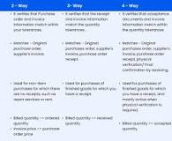](https://www.google.com/search?rlz=1C5CHFA_enDE926DE926&q=What+is+4+way+match+PO?&tbm=isch&source=iu&ictx=1&vet=1&fir=uO3KTSK7DaxctM%252C4Du8K3Ox2o70LM%252C_&usg=AI4_-kQ2TjO9wSW2SCkczsQ0yL-3EuU3FA&sa=X&ved=2ahUKEwjZv5DVlPv4AhVak_0HHW73CSEQ9QF6BAgNEAE#imgrc=uO3KTSK7DaxctM)](https://www.google.com/search?rlz=1C5CHFA_enDE926DE926&q=What+is+4+way+match+PO?&tbm=isch&source=iu&ictx=1&vet=1&fir=uO3KTSK7DaxctM%252C4Du8K3Ox2o70LM%252C_&usg=AI4_-kQ2TjO9wSW2SCkczsQ0yL-3EuU3FA&sa=X&ved=2ahUKEwjZv5DVlPv4AhVak_0HHW73CSEQ9QF6BAgNEAE" \l "imgrc=uO3KTSK7DaxctM)

In the 4-way matching process, **you match the invoice with the respective quantity and amount of purchase order, inspection information, and the receiving information**.

<https://tipalti.com/invoice-matching-explained/>

## Different Types of Invoice Matching

There are three common types of matching in [accounts payable automation](https://tipalti.com/ap-automation/), creating a two-way, three-way, or four-way match.

### **Two-Way Invoice Match**

This occurs when an invoice from a third-party is matched with a purchase order, tolerances are met, and the invoice is entered into a database.

### **Three-Way Invoice Match**

This happens when an invoice is matched with a purchase order, the receipt of goods, and a supplier invoice. All three components must match within agreed-upon tolerance levels. It is then entered into the AP system.

### **Four-Way Invoice Match**

Much like three-way matching, this process needs a purchase order, receipt of goods, and supplier invoice. To make it a four-way, it also requires inspection information.

This typically has to do with quantity tolerance. Once all 4 components match, the invoice is entered into the AP database.